

**Deliverable 2**

**Open Source Plastic Recycling Machine**

**Date :** 01/02/2022

**Groupe N° :** 14

**Names :** BIANCIOTTO Tom / CLAVEL Maxime / GASTON Louis / LEGARDEUR aaaaaaaaWilliam / LENNE Margaux / WILLIE Nsongurua Innocent

**SUMMARY**

**A. Context of the study - Main objective of the project** **3**

**B. Relevant (new) elements of State of the art** **4**

Shredding : 4

Drying : 4

Compacting and Melting : 5

**C. Current developments** **6**

Overview of the shredder : 6

Reductor choice : 8

Electrical part : 9

Actual structural view : 12

Compactor : 12

**D. Project task advancement and achieved work plan and risk analysis** **14**

**E. Project costs: cost structure, evaluation method** **16**

**F. Work Plan - objectives, Key elements, difficulties** **17**

**APPENDIX 1: GANTT chart** **18**

**APPENDIX 2: Risk analysis** **19**

**APPENDIX 3: Cost table** **20**

# **A. Context of the study - Main objective of the project**

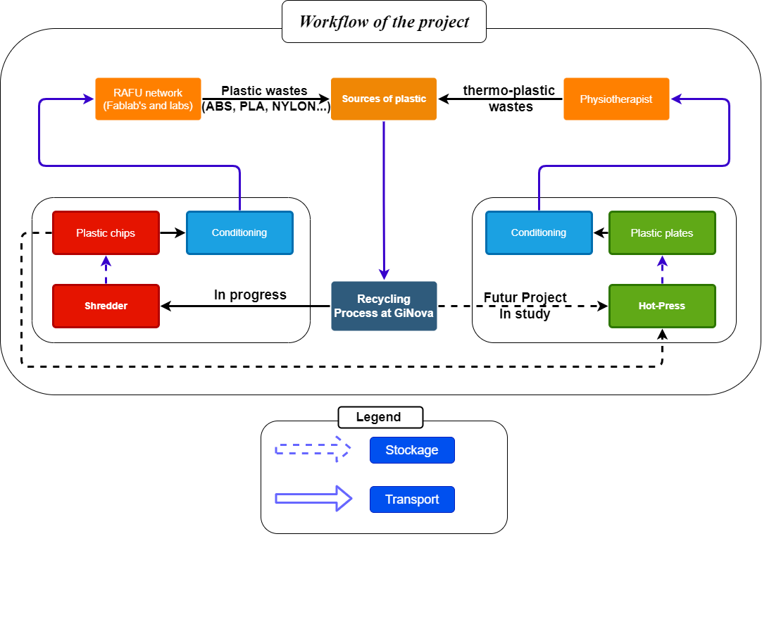

***Figure 1*** *: Workflow of the project*

The objective of our project can be summarized by finding a lowtech and open source solution to recycle different kinds of plastic waste. In our more specific situation the objective is to first provide a plastic recycling solution to the **RAFU network**. This network gathers the **labs** and **Fablab of the UGA.** The research and the craft made there, create plastic waste especially with the 3D printing process. It would be a huge improvement if it became possible to recycle this plastic. In the future this solution could be extended to other kinds of actors who use plastics such as **physiotherapists** who make splints with thermoplastic or industrial materials. (such as **Chabloz company** with nylon waste ?)

The objective of the group was to find a way to make the creation of 3D printing filament easier with the professional recycling machine available in the **fabMSTIC**. The main point of improvement is to work on the size of the pieces of plastic that had to be recycled. Another important phase is to organize the collection and the travel between the different recycling spots and users. Another point that could be developed is the creation of plastic plates to give a new life to the plastic collected.

To work on this project, the group was given a prototype of a plastic shredder and a hot-press. These two prototypes were not fully finished and need to be improved in a matter of capacity and mostly about safety to be used properly.

Since the first deliverable the work was focused between a fine study of the way to recycle plastic, the design of the prototypes improvement, and the creation of the Open source documentation on a [Git-Hub repository.](https://github.com/clavelma/shredder)

# **B. Relevant (new) elements of State of the art**

Our goal is to Recycle Plastic, but there are many different types of plastic, each with different characteristics, which means that they do not come from the same sources and cannot be recycled in the same way. It is therefore necessary to analyze these different plastics, their properties, their origin, their use. This will enable us to be more versatile and recycle the most suitable type of plastic possible.

**Endocrine Disruptors:** These are substances that mimic the role of hormones and disrupt their proper functioning.

After talking about the different types of plastic that are mostly found in landfills, we will detail here the few technologies used to recycle plastic in a low-tech philosophy :

## **Shredding :**

Shredders cut plastic items into small flakes ready to be turned into new things by the other machines, very useful for reducing the size of products to be recycled . The functioning of the shredder is quite simple, depending on the size of the parts to be shredded, we can use one or two blade rollers as shown on **Figure 10**. The manufacture of such a shredder can be done by cutting sheet metal, which is an efficient and cheap solution, an important point for us. The only part that is expensive is the motor needed to drive the knives, with a 300 Nm required torque.

*aa****Figure 2*** *: Example of cutting*

*blades on the existing shredder*

## **Drying :**

After having our flakes using the shredder, we can add a step to the recycling process ; drying. This step is not essential but preferable to ensure a better quality of the future molten plastic. In fact, often, moisture appears on plastics due to the humidity of the environment to which they have been exposed, this finally reduces the properties of the recycled materials. A low-tech and existing solution to dry plastic chips is to use an air exchange oven. This is certainly not the best solution but the most affordable. Industrial and expensive machines actually use a kind of “pop-horn” technology, the idea is to put plastic chips in a hopper and to blow hot air inside. More locally, the Ginova aa***Figure 3*** *: Dryer XU058* platform is equipped with the XU058 dryer ( figure 3) which uses iiiiiiiiiiiiiiiiiiiiiiiiiiiiiiiiiiiiiiiiiiiiiiiiiiiiithis technology. If it’s necessary, we can use it. 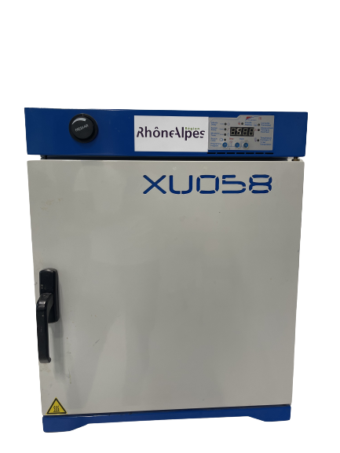

## **Compacting and Melting :**

The function of the compactor in our recycler is to transform small pieces of crushed plastic into molded plastic plates. For this purpose there are already several solutions, but the idea remains the same: the small pieces of crushed plastic are placed on an aluminum plate (or in a mold), the environment is heated to the melting temperature of the processed plastic (oven or hot plates) and the plastic is compacted with the help of a second plate.

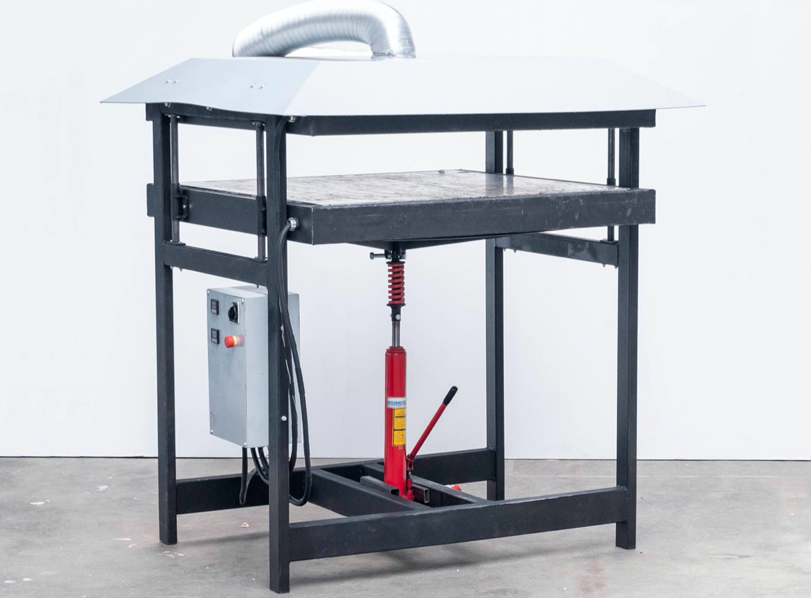 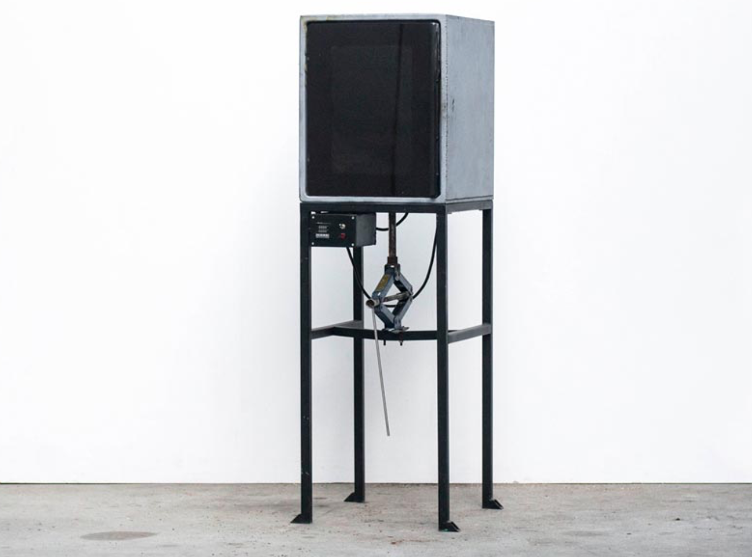

***Figure 4*** *: Pro Sheetpress [3]* ***Figure 5*** *: Basic compressor [3]*

Here we can see (*Figure 4&5*) two different solutions for this "compressor". Indeed, figure 4 is one of the best current options to do what we expect from our press, we can see that it is made so that the plastic (located on the lower plate) is compressed by the upper plate by a hydraulic press. The two plates are heated with resistances. We also notice that there is a smoke evacuation for safety because as seen previously, some plastics are dangerous for health and their filtration is necessary to avoid their inhalation and thus to handle the plastic without danger. In the second case (figure 5), much more low cost, plastic is heated inside the oven and slowly pressed into a mold with a carjack. Our goal is to be inspired by both methods in order to be as efficient as possible, at a price that is always affordable and, above all, while maintaining the necessary security. 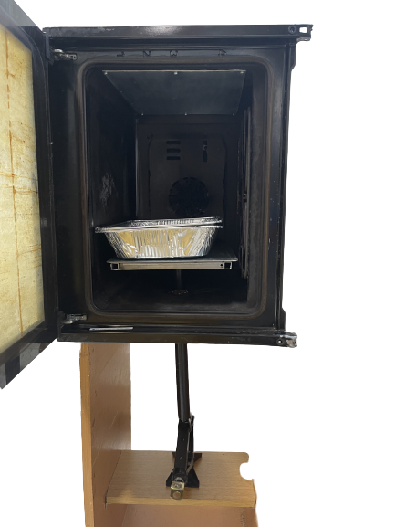

Guillaume Marin gave us a machine that uses the second technology. Unfortunately, there is not enough time to fully explore this prototype, but we have plans to design a virtual prototype. This virtual prototype will reflect possible improvements on the previous one, given by Guillaume Marin.

***iFigure 6*** *: Compressor prototype*

# **C. Current developments**

## **Overview of the shredder :**

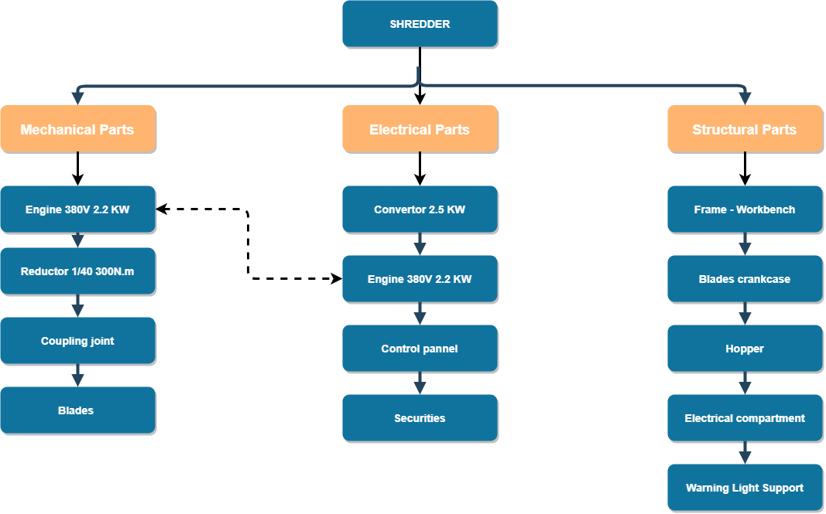

***Figure 7*** *: Overview of the shredder*

At the beginning, we had in mind to maximally use the equipment that was given to us, including a 60 N.m geared motor. In order to reuse as much material as possible, we wanted to assemble this motor with our shredder for testing purposes. We obtained the following assembly (***Figure 8***) :

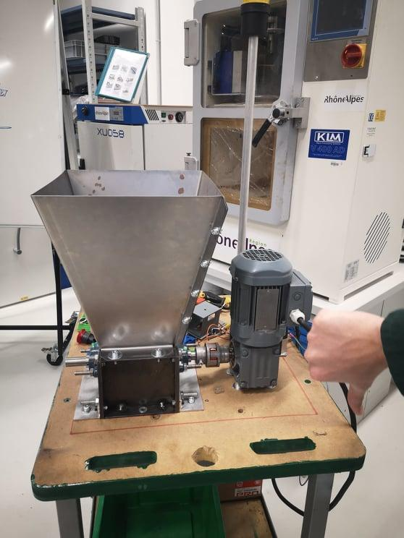

***Figure 8*** *: First assembly of the shredder*

This assembly only made it possible to grind very small pieces of plastic, so we realized that this geared motor would not be suitable: it develops too little torque to effectively overcome the force of the blades on the plastic pieces. It may seem that at this stage we have wasted a lot of time for nothing in trying to implement this solution but in reality it has taught us by experience some essential things for future choices such as: the choice of a coupling solution, the connection of the motor and the three-phase converter, the assembly/ disassembly and the adjustment of the shredder blades.

For the future, we decided to keep only our shredder on the trolley in order to carry out further dimensioning tests to choose the ideal transmission (we do not want to buy material without knowing if it will be suitable or not). At this stage we know that the solution will need a larger motor and gearbox, so the trolley will also have to be modified in the future to be suitable for this kind of material.

We now have to calculate the maximum transmissible torque of the input shaft of the shredder in order to size our transmission :

The diameter of the shaft is 20 mm at the input of the shredder but the section is thicker at the blades section : it is a hexagonal bar of 30 mm width in steel which has been machined on both ends to a diameter of 20 mm to ensure the passage of the bearings. To simplify our calculations, we will take a 25 mm diameter shaft with a constant thickness (D = 0.025m):

$I0 = \frac{ΠD{}^{4}}{32}$ = 3,8.10^-8 $RgSteel = 150 Mpa$

**Torsion limit (safety factor s=1) : $Γ=RgSteel/s$, so :**

$Mt=RgSteel*I0*\frac{2}{D}=460 N.m$

The maximum acceptable torque at the mill inlet is therefore **460 N.m** under these assumptions. Let us note this torque value $Cmax$.w

Determination of the minimum motor torque required for grinding:

During the first semester, we were able to set up the shredder without its motor as explained before ***(Figure 3)*** on a test table. Using a one-meter solid steel bar, we made an experimental tool to determine the minimum torque needed to start shredding ABS pieces previously stuck in the blades. As shown in Figure X, we placed weights at the end of the steel bar until the pieces started to crack under the effect of the blades. Since the bar is 1 m long and the angle is small, it is then sufficient to approximate the torsional moment using the following relationship (***Figure 4***):

$Mt = M*g*1$

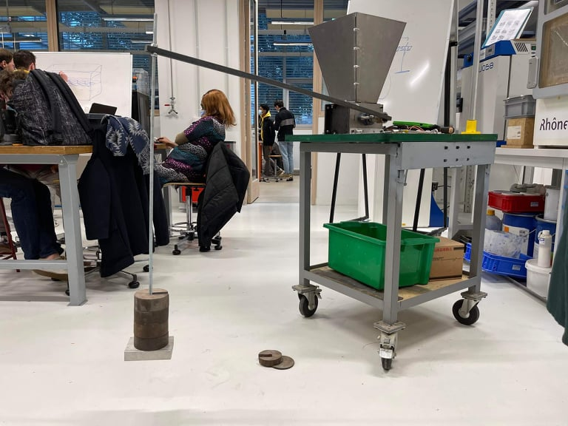 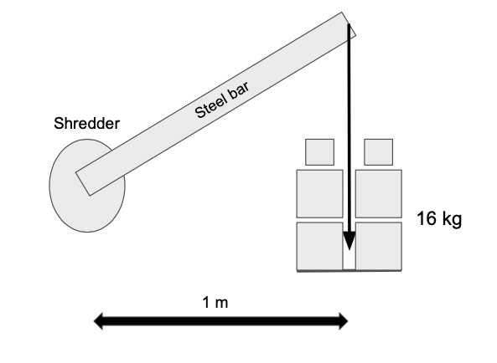

***Figure 9*** *: Picture of the experiment* ***Figure 10*** *: Diagram of the experiment*

With this simple approximation method, we find a necessary torque at the mill inlet of at least **160 N.m**. Let us note this torque $Cexp$.

## **Reductor choice :**

Mr.Di Donato from the Gi Nova platform provided us with a 2.2 kW three-phase Siemens motor. The unreduced output torque with this power is 7.33 N.m for N= 2865 rpm.

In summary, we still have to choose the gearbox size, we now know that the output torque must be between $Cexp$ and $Cmax$.

If we take a ratio of 1/40 :

* The output speed at the gearbox is **70 rpm**, which is the value recommended by the precious plastic website for this shredder;
* The output torque would be **293 N.m;**
* The torque obtained remains below the maximum admissible value $Cmax$.

Our choice will therefore be a 1/40 gearbox with a resistance torque of at least 300 Nm. According to Mr. DI Donato's recommendations, we will have to search for this kind of product in the **Motovario** brand, which is able to supply this type of reducer. If possible, we prefer to choose a gearbox that allows the motor to be placed vertically in order to reduce the final dimensions of our grinding station, the worm gearbox of the **NMRV** type seems to be the perfect candidate (***Figure 11***).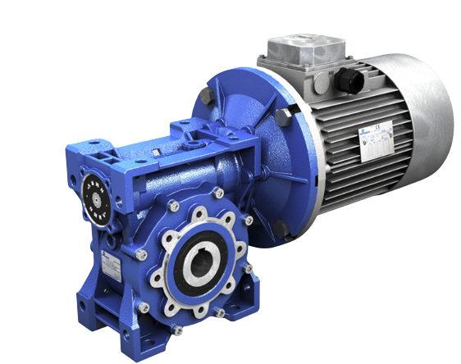

***Figure 11***

In the meantime, we have equipped our shredder with a hopper (***Figure 12***), which allows restricted access to the blades and therefore additional safety:

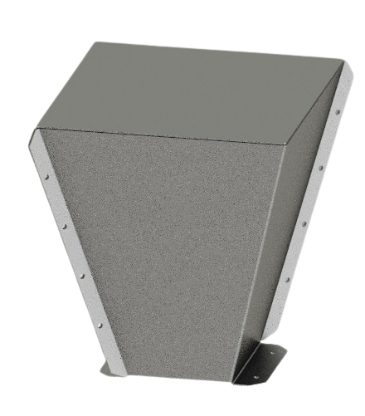 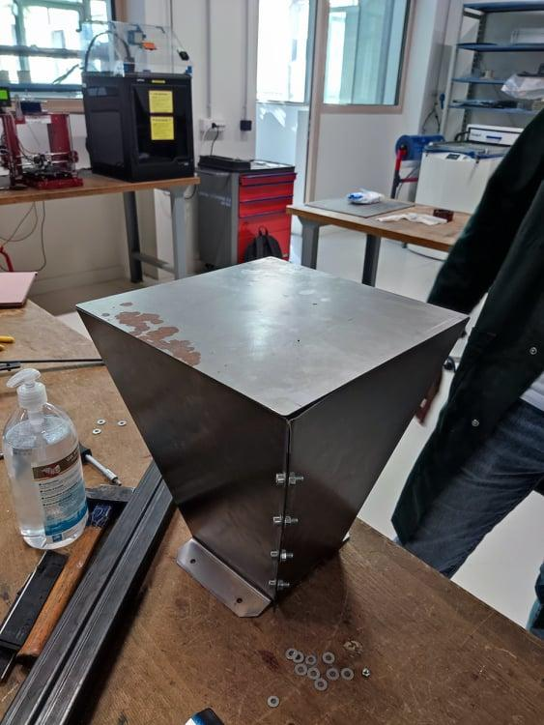

***Figure 12* :** *Hopper cut out at ENS3 by water jet cutting on a 1 mm steel sheet.*

## **Electrical part :**

To connect the shredder into a 200V standard plug, we need a power converter which changes the 2 phase 220 V current into a 3 phase 380V. For the first engine, the converter provided by GI-Nova was adapted for the power of the motor. Unfortunately if we had to change to a more powerful engine the actual converter is going to be unadapted because it supports an engine with a power under 1.5 kW.

This converter can then be used to connect the various components we need. To do this, we will use the different input terminals it has:

* Its analogue input will be used to connect an external potentiometer. This will allow the frequency of the converter to be controlled and therefore the speed of the motor to be varied.
* A three-position button will also be integrated so that the motor can be operated in one direction or the other or simply left at rest. To do this, it will be connected to the S1 and S2 inputs, being the two inputs that allow forward and backward operation [see diagram below]. An end-stop sensor will also be connected to these pins to switch off the motor if the hopper cover is opened during operation. This is a very important safety feature to prevent injury.



***Figure 13* :** *Pins available on the converter*

* Pins L1 and L3 of the converter are used to connect an emergency stop button. When this is pressed, the phase (L1) will be cut off. In order to restart the machine, a circuit breaker will have to be reset after the defect is identified and eliminated. On these pins there is also a 2-position button for switching the machine on or off.
* Finally, the motor will be connected to the output of the inverter, to pins T1, T2 and T3 as it is a three-phase motor.

To illustrate this, the final wiring diagram is shown below:

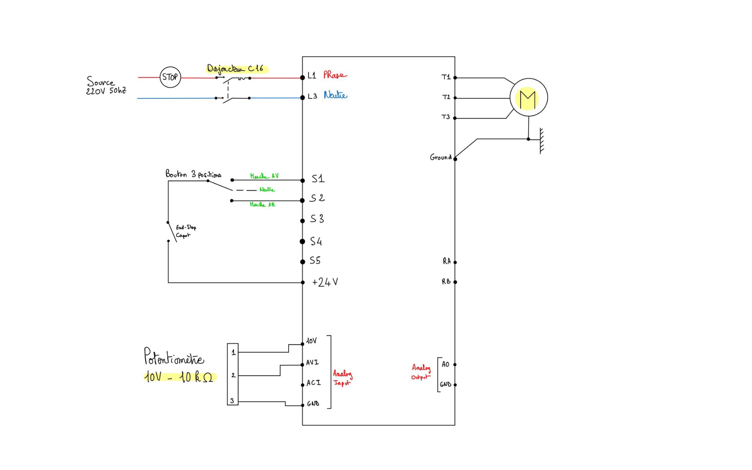

***Figure 14 :***  *Wiring diagram of the different components*

All the electrical devices involved in the realization of the shredder will be placed in an electrical box which will gather them. The box will contain the circuit breaker, converter, and emergency stop button. IIn front of this box there will be a control panel with the power button, the speed potentiometer, and the 3 positions switch. To do that, we plan to cut an aluminum panel at the ense3 Fablab.

For the rest of the project, we also plan to integrate a visual warning system to inform users that the shredder is in operation. The choice of this light signal was not made at random, we have researched the different types of signals relevant to the industrial environment.

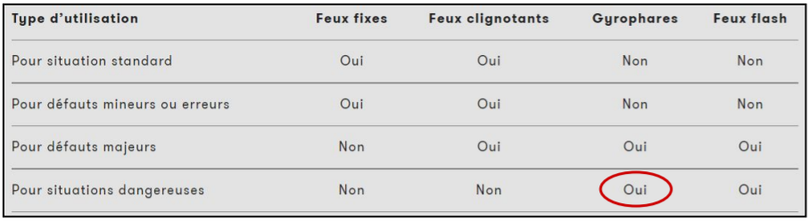

***Figure 15 :***  *Use of the light signal*

We note here that a flashing light seems to be suitable for our system. We will therefore use this solution as a light signal to inform about a dangerous situation.

## **Actual structural view :**

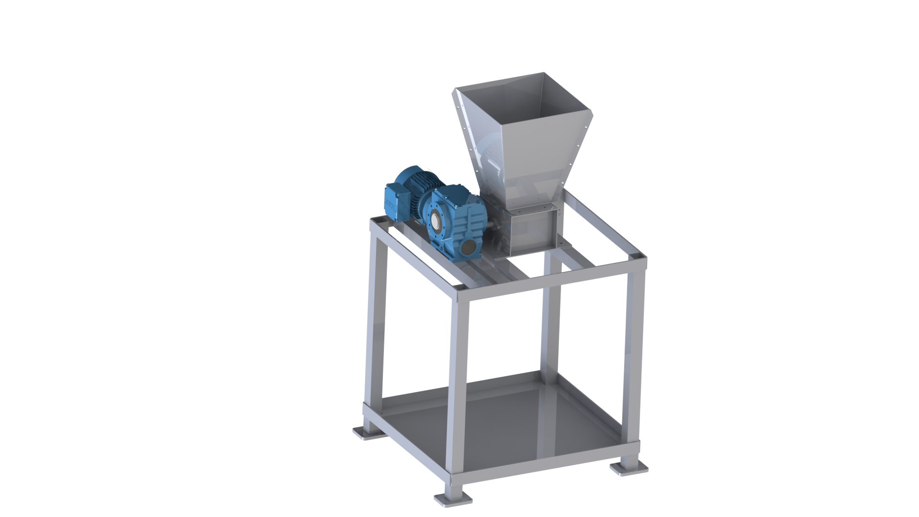

***Figure 16***

We have now to think about plastic chip recovery : the idea is to develop a drawer with 2 or 3 trays to temporarily stock the plastic chips according to the type of polymer we will shred (ABS, PLA, PET…).

## **Compactor** :

Having been very optimistic about the realization of our grinder and having underestimated the time and resources needed, we had been looking at a new solution, which would in fact be the logical continuation of our project and which would allow us to meet the expectations of other clients (secondary ones, such as Manuel François, the physiotherapist, who had asked us if it was possible to make plastic plates, molded, to make custom splints). It was also a project we had had from the beginning, because even though we had concentrated on the grinder, Mr Marin had presented us with the beginnings of a compressor: a furnace with two plates inside that are joined by a jack. However, it was far from being functional.

We then worked on the problem for a few sessions, our aim being on the one hand to make the oven safe, which seemed dangerous and conductive, but also and above all to make it more functional and efficient, by finding a way to make it better insulated and hermetic and a new solution for the compression between the two plates, which was not very well guided and caused the whole oven to rise when the jack was raised.

Our thinking led us to three main ways of improvement: the oven and its structure, the heating plates and an evacuation system.

As far as the oven itself is concerned, we were initially thinking of attaching the oven to its structure, in order to solve the problem of lifting the whole oven with the jack, and to secure the oven, initially by reviewing the electrical wiring so that it would be better insulated. One of our concerns was also the addition of glass wool all around the kiln, to better maintain the heat. Then, concerning the improvements, we were thinking of adding a thermostat and a thermometer to manage the temperature inside the oven as well as rethinking the door, which at the moment is not very practical, it closes by itself, so maybe just remove the spring.

Then, having been inspired by some existing solutions, we wanted to include heating plates to our compressor. Indeed, in addition to having a warm environment, the plastic would melt and compress all the more when in contact with heated aluminum plates. However, this solution is still to be reviewed (thermal shock reaction of the plastic especially...)

Finally, still with a view to safety but also to meet environmental standards, we had thought of including a smoke evacuation system. This would be composed of aluminum tubes allowing the evacuation by connecting the inside of the oven to an active carbon filter to avoid any intoxication and degradation of the air in general.

To help us in our thinking and sizing, we started a 3D model of the oven, far from being complete but sufficient for our use:

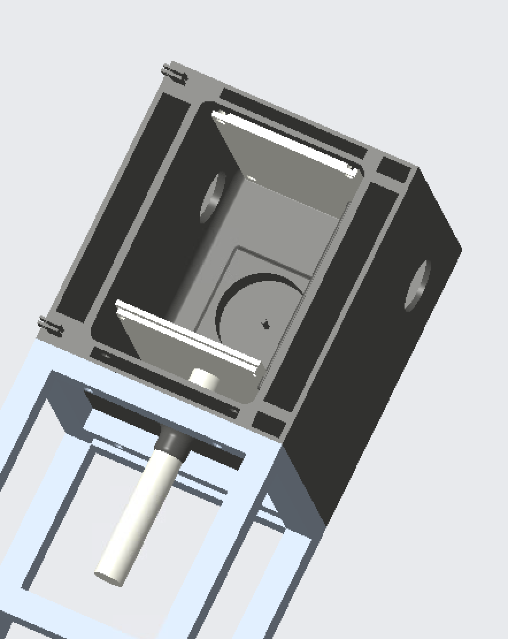 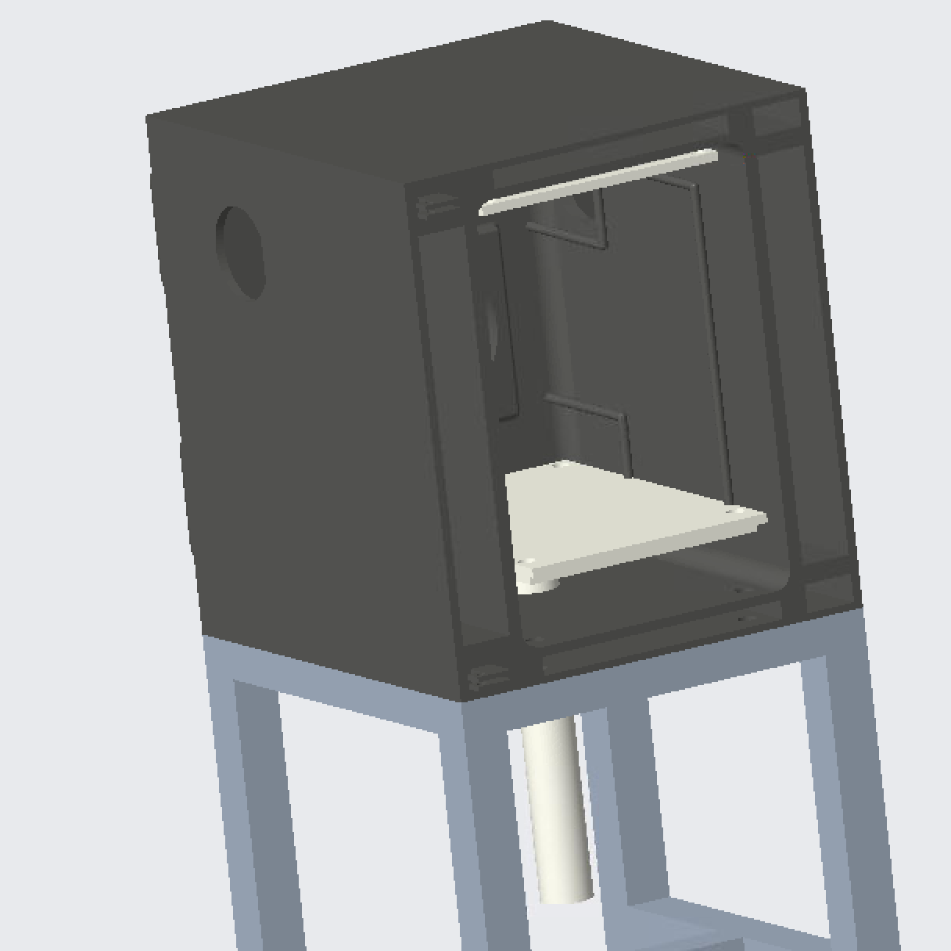

***Figure 17 Figure 18***

***Please note that all the final 3D plans of the project will be deposited in free access on the sharing platform thingiverse.com and on our*** [***github***](https://github.com/clavelma/shredder) ***repository.***

# **D. Project task advancement and achieved work plan and risk analysis**

Since the last deliverable, 8 weeks have passed. During these weeks, we were able to finish some tasks on time, such as task M concerning the 1st phase of research on the press [see appendix 1]. However, thanks to the first tests on the shredder after the Christmas holidays, we realized that the motor was unable to shred ABS pieces [see details in part F. Work Plan - objectives, Key elements, difficulties]. Although we had expected this problem in the risk analysis, it turned out that the criticality had been underestimated as can be seen in the risk analysis extract below.

| **Risk family** | **Risk** | **ID** | **Description** | **Severity** | **Occurence** | **Criticality (E*F)** | **Solution identified if risk is encountered** |
| --- | --- | --- | --- | --- | --- | --- | --- |
| **Performance** | The motor is of a low torque, therefore not enough to shred the plastic | 11 | Shredder jams, runs at too low a speed | 1 | 1 | 1 | To change the motor and/or the reduction gear |

***Figure 18*** *: Extract of the risk analysis*

Inevitably, we began to fall behind on critical path tasks of the gantt chart revision 2, in particular task **I "Improvement of the shredder"** and **N "Improvement of the press"**. In week 4, we decided to carry out a major organizational overhaul which resulted in major modifications of the gantt and therefore a new revision. We refocused the objectives in a big brainstorming session, and the decision that came out of it was to concentrate on the shredder until the end of the project and to give up the idea of being able to present a working prototype of the press [see details in part F. Work Plan - objectives, Key elements, difficulties]. We have therefore replaced task **N "Improvement of the press"** of the Gantt revision 2 with **"Hot press state of the art"** which will consist of the following subtasks :

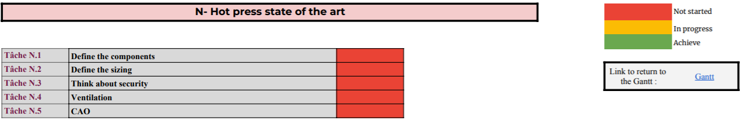

***Figure 19*** *: Subtasks of the task N ‘Hot press state of the art’*

Another change was to create a new task: **'Shredder supply chain'**. This one will start in week 11 and will be used for example to ensure the traceability of the plastic chips and to know the different operations they have undergone :

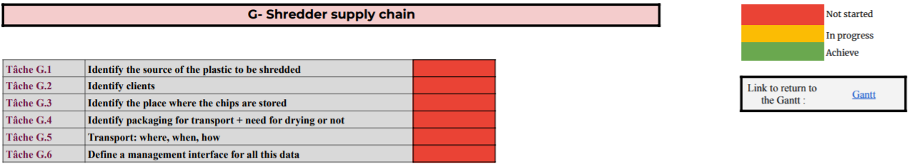

***Figure 20*** *: Subtasks of the task G ‘Shredder supply chain’’*

For the next few weeks, we will focus on improving the shredder and writing open source documents on the github site.

Concerning the risks, the most important one experienced at this phase of our project is with the performance of the shredder as it was explained just above. Indeed, the motor that was initially left for us to use was of a low torque, hence the shredder could not effectively shred the plastics. Our next step was to measure an estimate of the amount of torque that will enable our shredder work effectively, therefore, a new motor is needed.

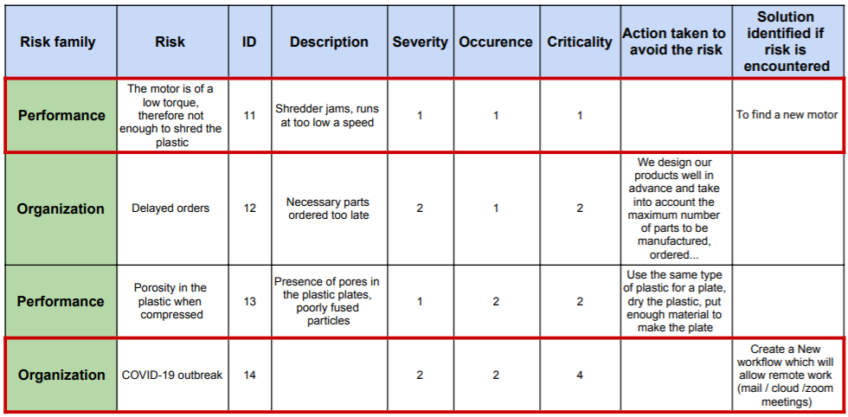

***Figure 21*** *: Extract of the risk analysis*

Another risk added to the documentation is the outbreak of COVID-19 amongst some team members. This risk was encountered when a member of our team was absent on the 4th January, 2022. This did not have any adverse effect on our work as we opted to work from home just for that period.

During the examinations, we could not advance on our project as we were all occupied with other projects and the first semester exams. In other words, we will have to adjust our planning to reflect the days that were missed. It is also paramount to state that no new risk has been added to the current list as we are yet to identify any.

# **E. Project costs: cost structure, evaluation method**

As for the costs, Guillaume Marin sent us an excel file where the costs of his work were listed (see appendix). We then completed this cost analysis by adding everything we were doing: the raw material (metal for the hopper), the gear motor part, the electronic parts, but also the machining and manufacturing costs, the finishing costs and finally we added the operator and machine costs.

For all the parts, and activities, that we added or modified in our mill (in color “salmon” in the appendix), we looked for their corresponding price in order to be able to calculate the final cost of our product. However, many of them were given to us, which makes them salvageable and therefore something to be taken into account in the final cost calculation as many parts can be salvaged. This would reduce the costs considerably because, for example, one of the parts that seems to be easily recoverable is the engine, which is worth about 20% of the project at the moment.

Finally, we have quantified the machine and operator costs. For the machines, we calculated their hourly rate and estimated the time spent on them (with adjustments as this is not a mass production project...). Then, for the operator cost, we multiplied the average hourly rate of an operator in France by the time we spent on "industrial" machines, such as the lathe or the waterjet cutter for example. Indeed, as the aim is to make it a personal project, we estimate that the person who will make this shredder will have a minimum of tools and will therefore be able to do certain elementary operations without having at his disposal the big machines that we can have in companies or fablab for example.

At the moment, the budget for our project is about 2 100€. This sounds like a lot, but as we said before, many parts can be recovered, besides the gear motor part, which costs almost 900€, i.e. 43% of the total price, there is a large part of the electrical part (potentiometers, end stop sensor...). Also, we have put a lot of emphasis on safety on our product, which increases the costs considerably. Indeed, just the yellow LED flashing light costs 225€, i.e. 10% of the price, but also the circuit breaker in case of emergency stop or other component problems for example.

# **F. Work Plan - objectives, Key elements, difficulties**

As it can be read in this deliverable, the group had surely underestimated the difficulty to make a shredder that could work in only one semester. We haven't taken enough into account the necessity to have a huge amount of torque. So the group made a meeting in order to clarify the situation and define more realistic objectives for the rest of the project.

About the hot press the prototype is less developed than the shredder so we decided to not try to make a full prototype and just make a study on the different kinds of press that exist to define which one is better to make plastic plates. We want to make some studies about the temperature we want to reach for the different kinds of plastic, toxicity of the fumes and simply make some mechanical studies to prepare a future design.

For the shredder, we want to finish the prototype properly and have a working plastic shredding solution. We want to make a fine study of the torque needed to make plastic chips. A research of a couple engine/reductor that can provide the power needed. And more particularly focus on safety : the shredder had to be usable in an industrial context without any security issue.

Another main point of the project is to organize the logistics of the plastic waste. We need to analyze the stakeholders who want to use the recycling solution, the best way to transport the plastic, the frequency, and the condition of transport. The plastic often needs to be dried. We had to discuss when, in the cycle, it is more interesting to do that. Moreover another discussion could be about a means of communication between the numerous actors of the recycling circle to coordinate the process and trace the plastic.

Finally we want to keep the effort on the documentation we try to make as documentation as possible on the Github repository in order to keep our project open source. The first job would be to migrate our work to a new template more adapted to our needs.

We had encountered some difficulties with the prototype and especially the engine but the new objectives had created a new motivation in the group to make the project move forward. With the Gantt REV.3 everyone knows what they have to do and with reachable objectives it is easier to start a task.

# **APPENDIX 1: GANTT chart**

Link to go to the drive with the gantt chart (to see the sub-tasks): <https://docs.google.com/spreadsheets/d/1zl9KApmCFzgjy7fXfSUUbfGAa_7RfqJYZSNwacTICsc/edit?usp=sharing>

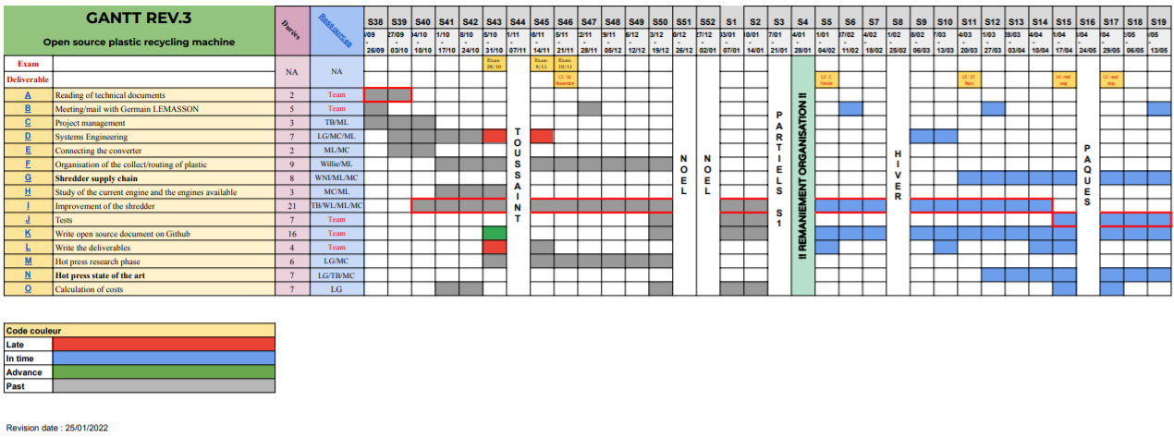

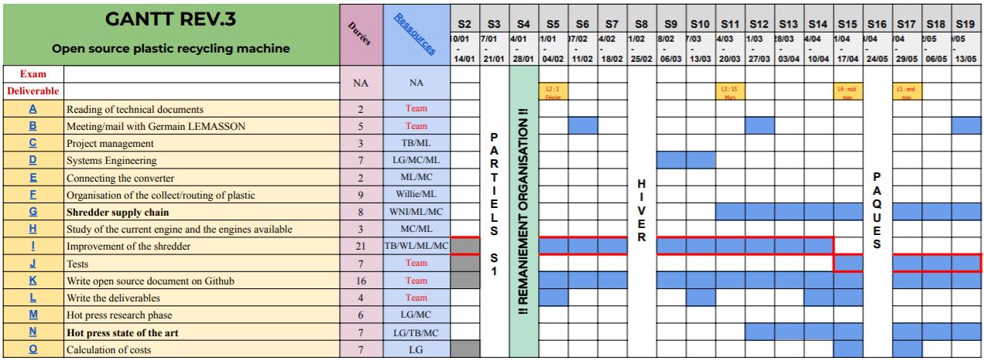

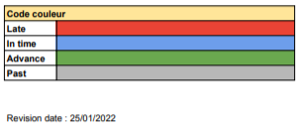

# **APPENDIX 2: Risk analysis**

# 

# **APPENDIX 3: Cost table**

Link to go to the drive with the cost table (to see the table in larger size):

<https://docs.google.com/spreadsheets/d/18o8vKLldMno5jiXbUUZbx3Ocs_Q6Qh4J/edit?usp=sharing&ouid=102232567855854021462&rtpof=true&sd=true>

